iPortal Installation Guide

**NOTE**: The installation instructions assume the windows machine name where Qlik Sense Enterprise is installed is named **qlikserver**. If that is not the case, you will need to replace **qlikserver** with the windows machine name for your computer.

**PREREQUISITE**: The iPortal installation can use either the Excel ODBC or ODBC (csv) to configure the User Directory Connector (UDC). You may need to install the Microsoft Access Database Engine to get these drivers.

1. Extract **iPortal.zip** to the folder **<Qlik Sense Install Directory>\ServiceDispatcher\Node** on the machine running Qlik Sense Enterprise (the zip file contains a root directory named iPortal so the extracted application should be located in the folder **<Qlik Sense Install Directory>\ServiceDispatcher\Node\iPortal**.
2. Copy the contents of **<Qlik Sense Install Directory>\ServiceDispatcher\Node \iPortal\services.conf** and paste it into **<Qlik_Install_dir>\ServiceDispatcher\services.conf**. Restart the **Qlik Sense Service Dispatcher** Windows Service.
3. Create a new **VirtualProxy** within the Qlik Sense QMC as defined below.

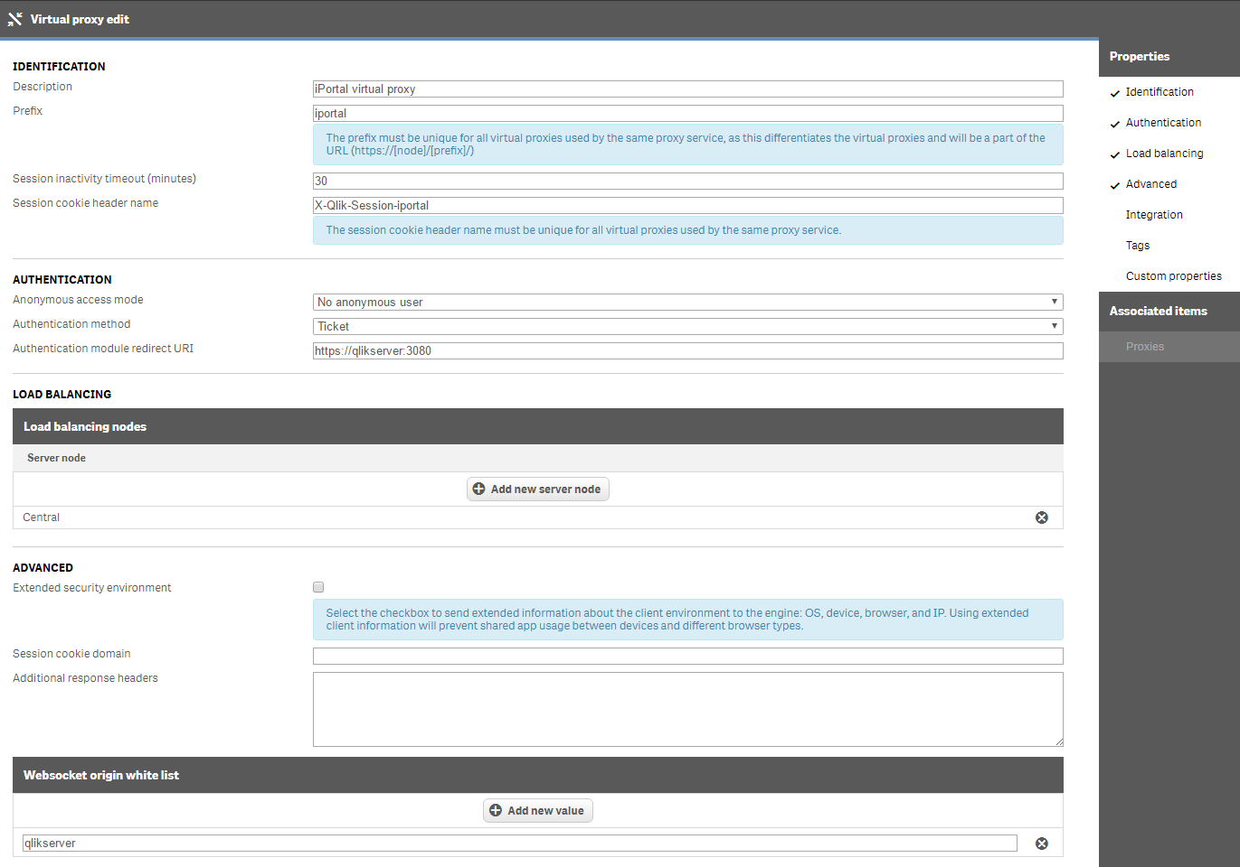

**Description**: iPortal virtual proxy  
**Prefix**: iportal  
**Session cookie header name**: X-Qlik-Session-iportal  
**Authentication module redirect URI**: <http://qlikserver:30>80  
**Load balancing nodes**: <Make sure Central node is added>  
**Websocket origin white list**: qlikserver

1. Select **Proxies** from the **Associated Items** tab menu on the right side of the page and select **Central** from the Node list. Click the **Link** button to complete the action.

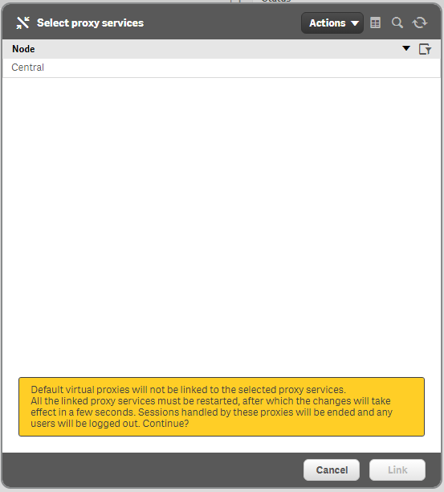

1. Create a User Directory Connector for the iPortal users. Data files are provided for an Excel or CSV based UDC. Instructions for a CSV based UDC are provided in step 5a while instructions for an Excel based UDC are provided in step 5b. You only need to configure **one**.

**NOTE**: The iPortal application is currently designed to read the list of users and attributes from the local_users_db.xlsx file. If you configure the CSV UDC, you will still need to edit the Excel file to match the CSV files content (in the event you make changes). This will ensure the list of iPortal users and attributes matches Qlik Sense. *** This will be corrected in a future release ***

* 1. Create a new CSV based **User Directory Connector** within the Qlik Sense QMC as defined below. You may need to download and install the Microsoft Access ODBC drivers on the computer where Qlik Sense is installed.

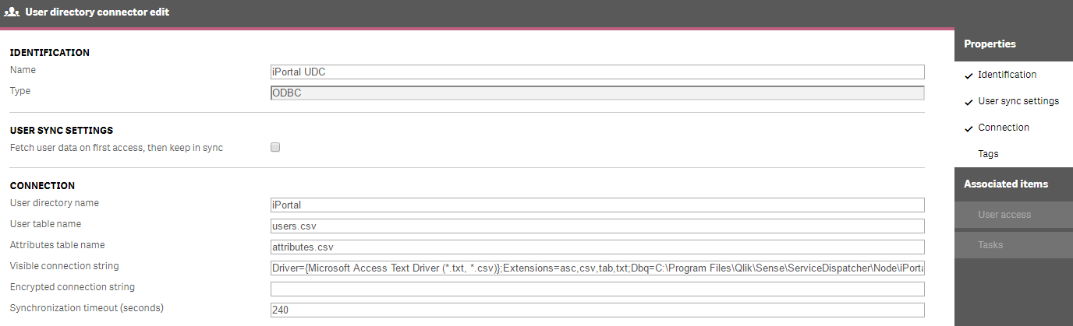

**Name**: iPortal UDC  
**Type**: ODBC  
**User Sync Settings**: Make sure the checkbox is **unchecked**  
**User directory name**: iPortal  
**User table name**: users.csv  
**Attributes table name**: attributes.csv  
**Visible connection string**: Driver={Microsoft Access Text Driver (*.txt, *.csv)};Extensions=asc,csv,tab,txt;Dbq=C:\Program Files\Qlik\Sense\ServiceDispatcher\Node\iPortal\udc

* 1. Create a new Excel based **User Directory Connector** within the Qlik Sense QMC as defined below. You may need to download and install the Microsoft Access ODBC drivers on the computer where Qlik Sense is installed.

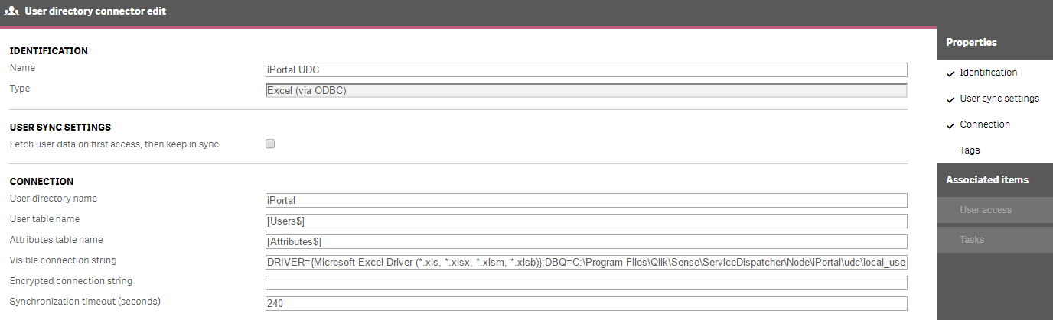

**Name**: iPortal UDC  
**Type**: Excel (via ODBC)  
**User Sync Settings**: Make sure the checkbox is **unchecked**  
**User directory name**: iPortal  
**User table name**: [Users$]  
**Attributes table name**: [Attributes$]  
**Visible connection string**: DRIVER={Microsoft Excel Driver (*.xls, *.xlsx, *.xlsm, *.xlsb)};DBQ=C:\Progam Files\Qlik\Sense\ServiceDispatcher\Node\iPortal\udc\local_users_db.xlsx

1. Add a **User access rule** to grant all users from the **iPortal** User Directory a user access token.

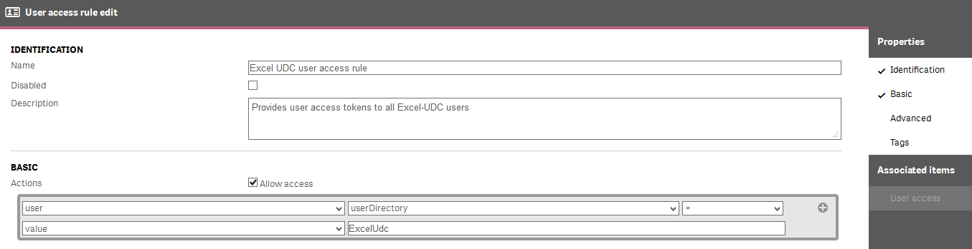

1. Open a browser and access https://<machine-name>:3080 or https://<machine-name>/iportal/hub and you will be presented with the iPortal!